**Report of Task 2**

**Backend**

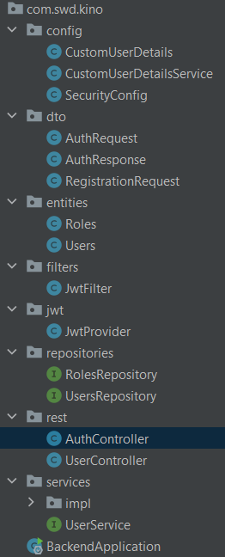

Auth Controller:

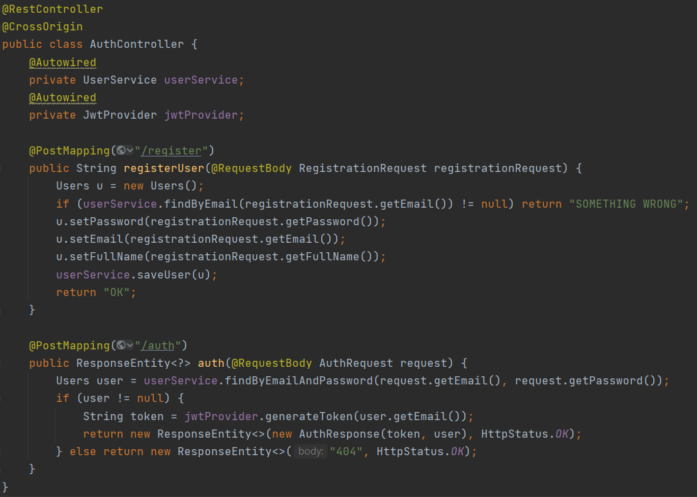

User Service:

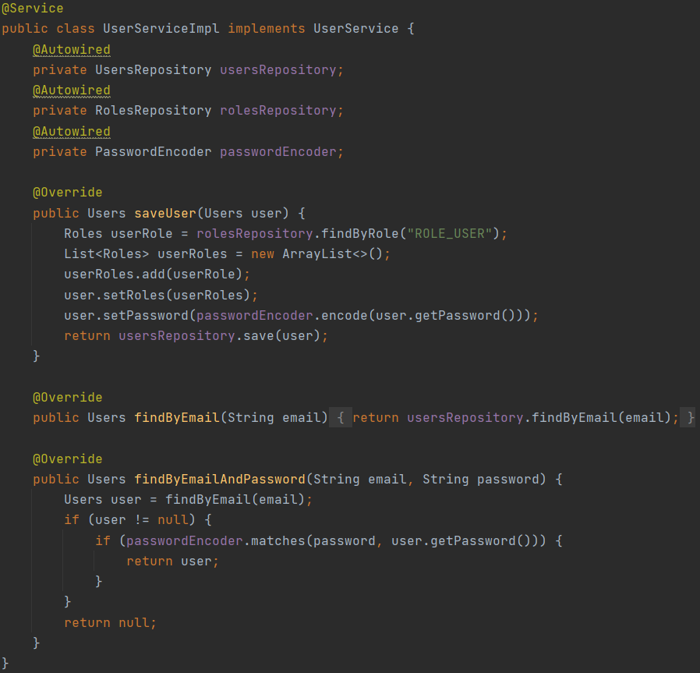

Security Config:

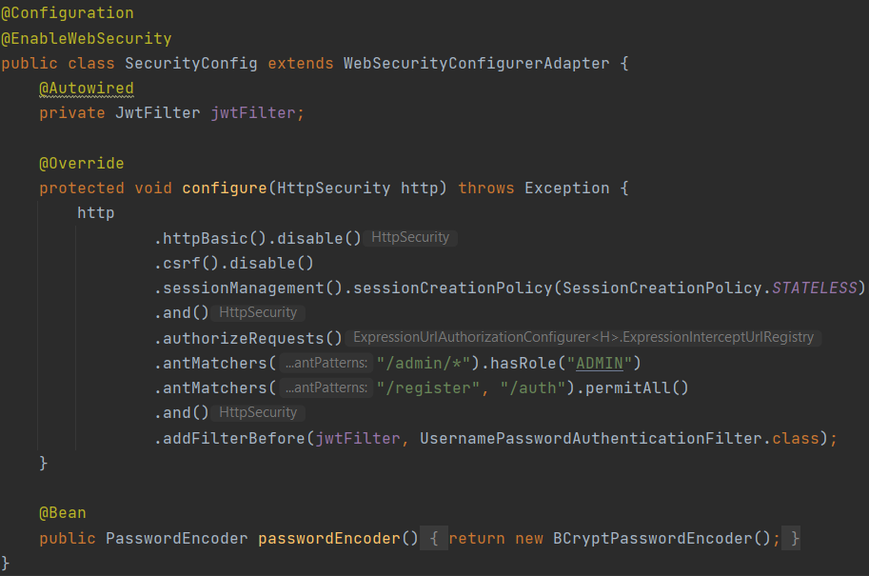

**Frontend**

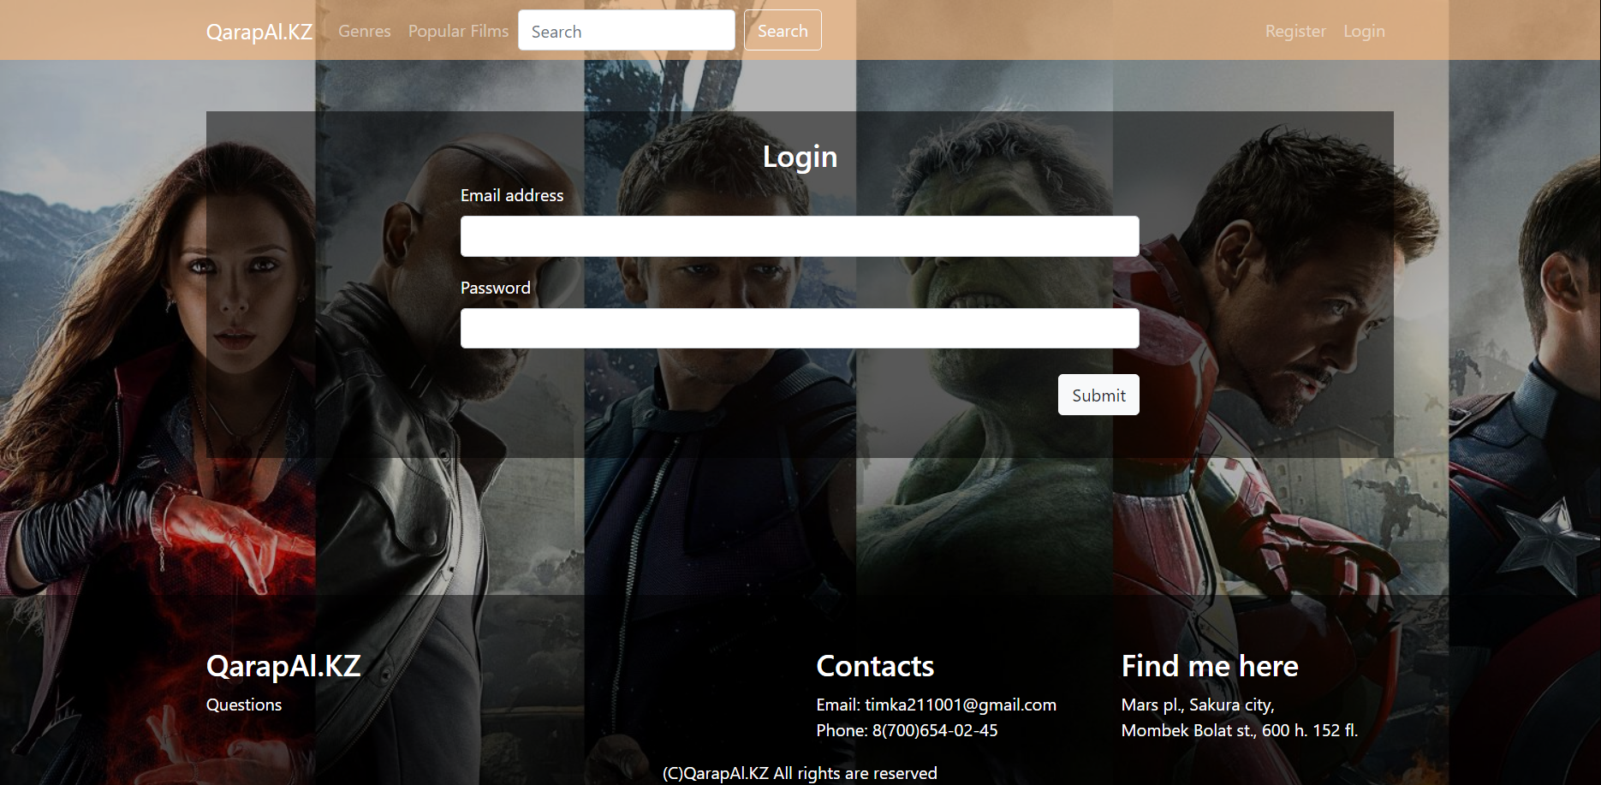

*Login page (on React)*

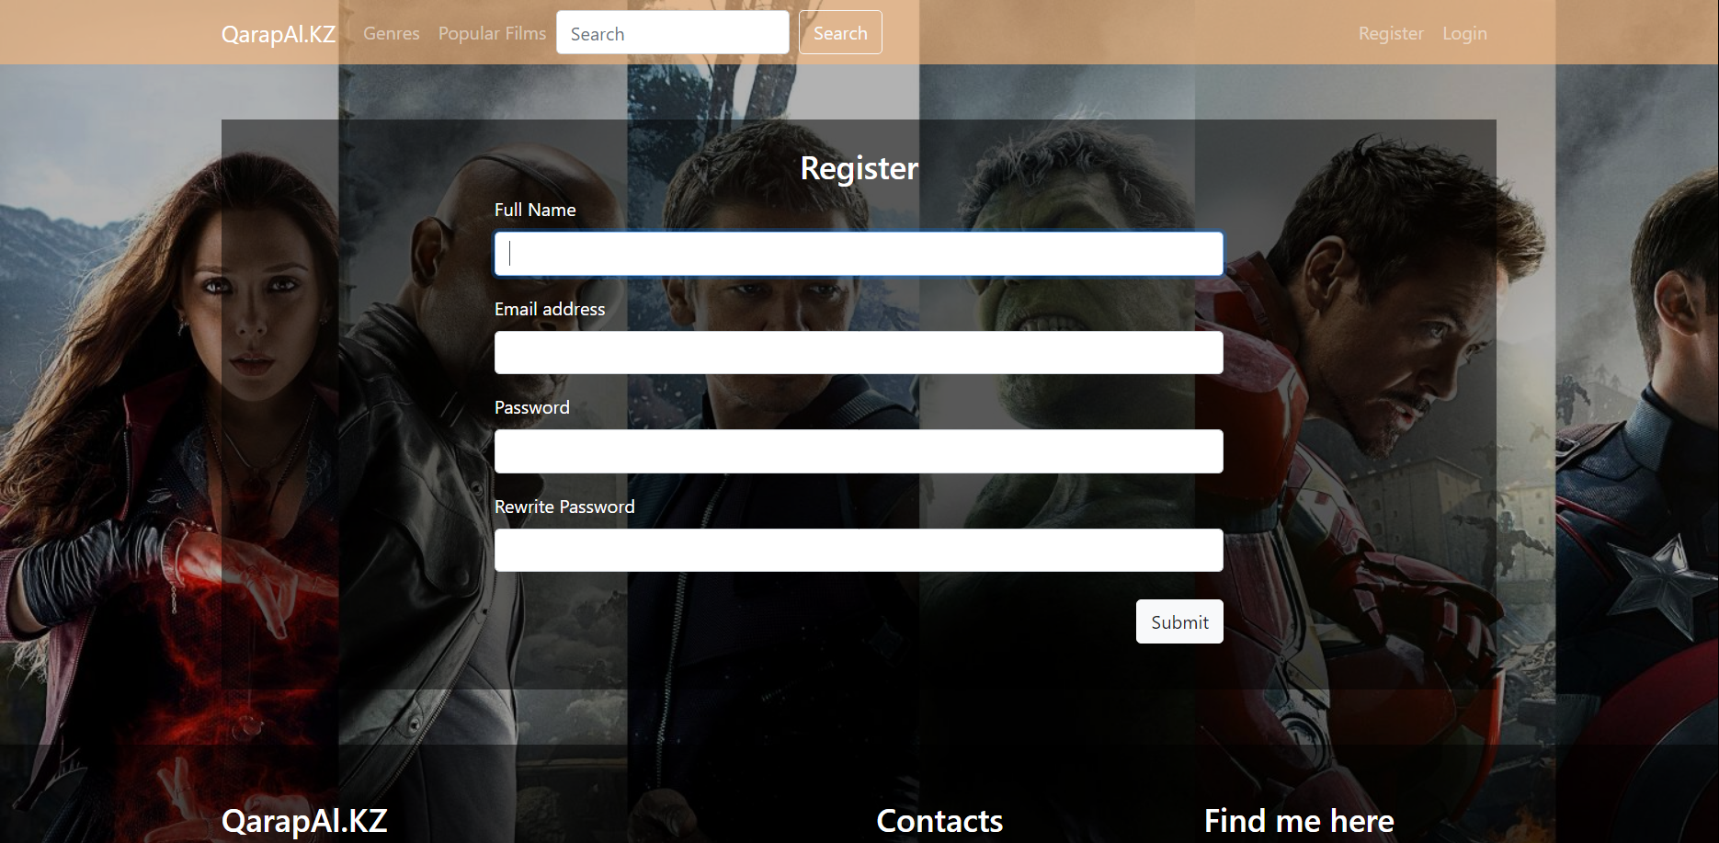

*Register Page (on React)*

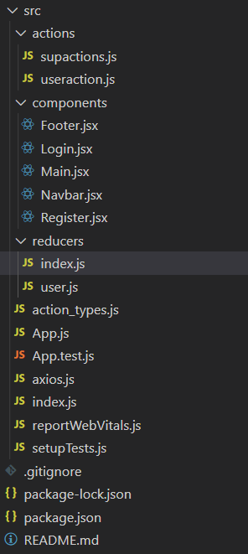"dependencies": {

    "@testing-library/jest-dom": "^5.11.10",

    "@testing-library/react": "^11.2.6",

    "@testing-library/user-event": "^12.8.3",

    "axios": "^0.21.1",

    "bootstrap": "^4.6.0",

    "bootstrap-icons": "^1.4.1",

    "react": "^17.0.2",

    "react-bootstrap": "^1.5.2",

    "react-bootstrap-icons": "^1.4.0",

    "react-dom": "^17.0.2",

    "react-multilevel-dropdown": "^2.0.0",

    "react-redux": "^7.2.3",

    "react-router-dom": "^5.2.0",

    "react-scripts": "4.0.3",

    "redux": "^4.0.5",

    "web-vitals": "^1.1.1"

  }